AWS SECURITY GROUP AND JUMP SERVER

AWS Security Group : An AWS security group acts as a virtual firewall that controls the inbound and outbound traffic for resources within an Amazon Virtual Private Cloud (VPC).

AWS Jump Server : A jump server also known as a bastion host is an Amazon EC2 instance deployed in a public subnet to provide secure access to other instances in private subnets.

Let us setup an example Scenario

WEB SG APP SG

PUBLIC SUBNET 2 PRIVATE SUBNET 1 PRIVATE SUBNET 2

users

DB

WEB

APP

Jump sg

JUMP

SERVER

PUBLIC SUBNET1

STEP-1 : Create VPC

* Go to <https://aws.amazon.com>.
* Sign into console home and search for VPC in search bar.
* Then click on create VPC.
* Resource to create :VPC and more
* Name : zeptovpc
* IPV4 CIDR block : 10.90.0.0/16
* No of availability zones : 2
* No of public subnets : 2
* No of private subnets : 2
* VPC end points : None
* NAT gateway : None
* Then click on create VPC.

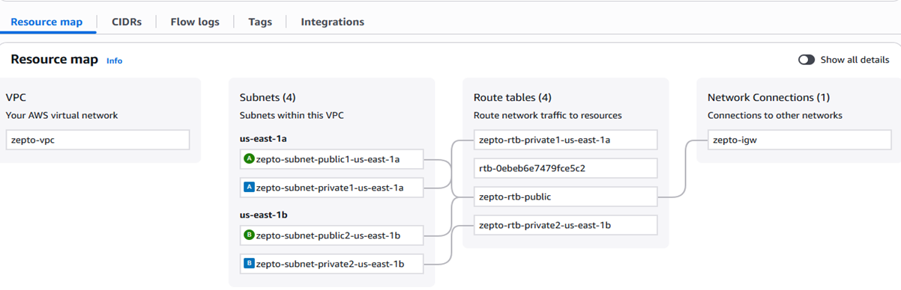

STEP-2 : Launch instance

ZEPTO WEB SERVER

* Go to EC2 then click on launch instance.
* Name : zeptowebserver
* AMI : ubuntu 22.04 LTS (HVM),SSD volume type
* Instance type : t3.micro
* Create new key pair : zeptowebserver key
* Edit the network settings.
* Select your public subnet 2 and enable IP.
* Then click on launch instance.
* After that click on connect.
* Next click that server id that page is open .
* Click on SSh client copy that command.
* Go to downloads there is zeptowebserverkey open with gitbash and paste that command on it then click on enter.

JUMP SERVER

* Go to EC2 then click on launch instance.
* Name : jumpserver
* AMI : ubuntu 22.04 LTS (HVM),SSD volume type
* Instance type : t3.micro
* Create new key pair : zeptowebserver key
* Edit the network settings.
* Select your public subnet 1 and enable IP.
* Then click on launch instance.

STEP-3 : Create Security group

WEB SECURITY GROUP

* Go to security group.
* Name : zepto-web-nsg
* Select vpc : zeptovpc
* Add inbound rules .

\*Type : SSH

\*Source : Custom

\*Type : HTTP

\*Source : Custom

* Outbound rules.

\*Type : SSH

\*Destination : Custom

* Then click on create security group.

APP SECURITY GROUP

* Go to security group.
* Name : zepto-app-nsg
* Select vpc : zeptovpc
* Add inbound rules .

\*Type : All traffic

\*Source : Custom

* Outbound rules.

\*Type : All traffic

\*Destination : Custom

* Then click on create security group.

JUMP SERVER SECURITY GROUP

* Go to security group.
* Name : jumpserver-nsg
* Select vpc : zeptovpc
* Add inbound rules .

\*Type : SSH

\*Source : My IP

* Outbound rules.

\*Type : All traffic

\*Destination : Custom

* Then click on create security group.

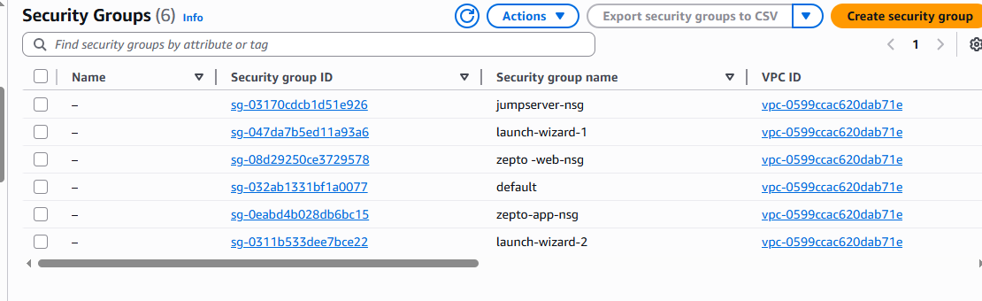

* First go to zepto-subnet public1 copy that IPV4 CIDR address.
* Next go to zepto-web-nsg edit inbound rules in that source paste that IPV4 CIDR address.
* Save that rules.
* Go to jumpserver instance after that click on connect.
* Next click that server id that page is open .
* Click on SSh client copy that command.
* Go to downloads there is jumpserverserverkey open with gitbash and paste that command on it then click on enter.
* Next go to zeptowebserver overview page copy that private Ipv4 address.
* Ping 10.90.22.125(your ip address) enter that command.

